Solving the 8-Puzzle using A* Search Algorithm

Programming Project 1

Intelligent Systems

Submitted by-

Sahil Rasane(801135252)

1.PROBLEM FORMULATION:-

The 8 puzzle is made up of eight numbered tiles in a 3x3 frame. One space is always empty. The goal of the puzzle is to reach the goal state desired, in most cases it is the ascending arrangement of the numbers from a jumbled configuration.

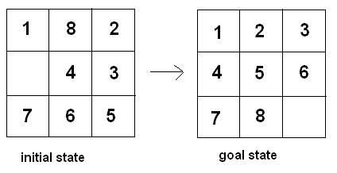

The actions one can perform are up,left,right,down.

2.A* Search:-

The A* search is used to find the path from the initial to the goal state. Each move is considered as a new state. It selects the next state on the basis of value-‘f’ which is a parameter equal to the sum of two other parameters – ‘g’ and ‘h’. At each step it picks the node/cell having the lowest ‘f’, and process that state.

f(n)=h(n)+g(n)

Here h(n) is the heuristic function and g(n) is the path cost from the initial state

A* terminates when the path it chooses to extend is a path from start to goal or if there are no paths eligible to be extended. The heuristic function is problem-specific. If the heuristic function is admissible, meaning that it never overestimates the actual cost to get to the goal, it returns a least-cost path from start to goal.

A* uses a priority queue(fringe) to perform the repeated selection of minimum (estimated) cost nodes to expand. This priority queue is known as the open set or fringe. At each step of the algorithm, the node with the lowest f(x) value is removed from the queue, the f and g values of its neighbors are updated accordingly, and these neighbors are added to the queue. The algorithm continues until a goal node has a lower f value than any node in the queue (or until the queue is empty). The f value of the goal is then the cost of the shortest path, since h at the goal is zero in an admissible heuristic.

The algorithm described so far gives us only the length of the shortest path. To find the actual sequence of steps, the algorithm can be easily revised so that each node on the path keeps track of its predecessor. After this algorithm is run, the ending node will point to its predecessor, and so on, until some node's predecessor is the start node. The algorithm terminates when the goal state is reached.

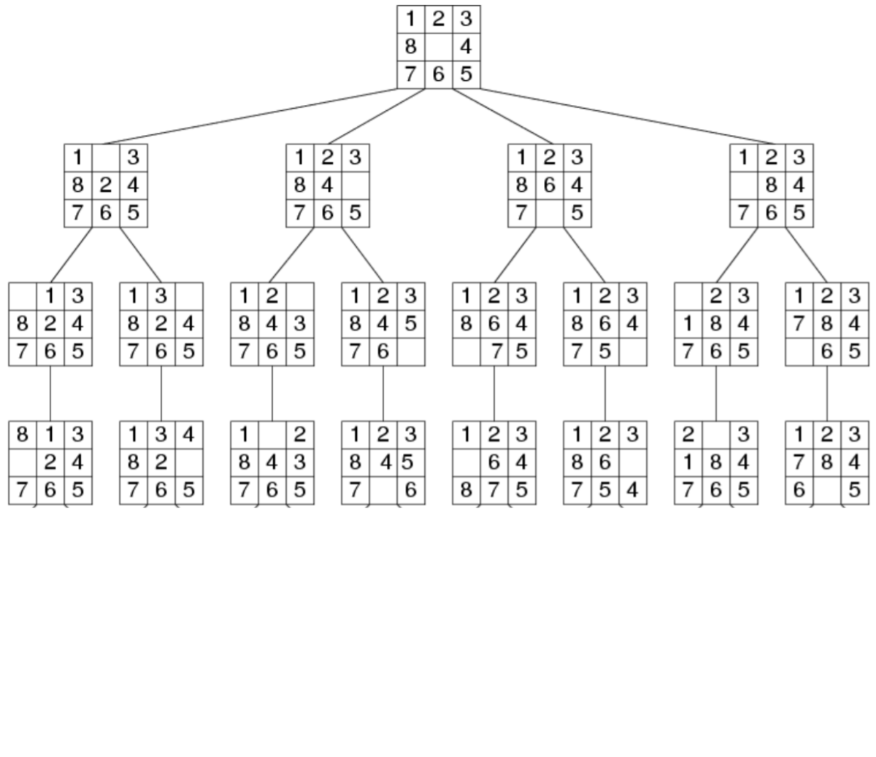

3.PROGRAM STRUCTURE :-

3.1 GLOBAL VARIABLE :-

Two variables expanded and fringe (priority queue) are used in solve ,which is our function to solve A* algorithm.

3.2 FUNCTIONS & PROCEDURES :-

next() : Function to generate next states from the current node.

Path() : Function used to print the path from the initial state to the goal state with statecost as 1 per action.

solve() : Function to solve using A* algorithm.

manh() : Function to calculate Manhattan Distance.

miss() : Function to calculate Misplaced tiles.

printState() : Function to print the state in a 3x3 matrix.

userInput() : Function to accept initial and goal states from the user.

3.3 SOURCE CODE :- 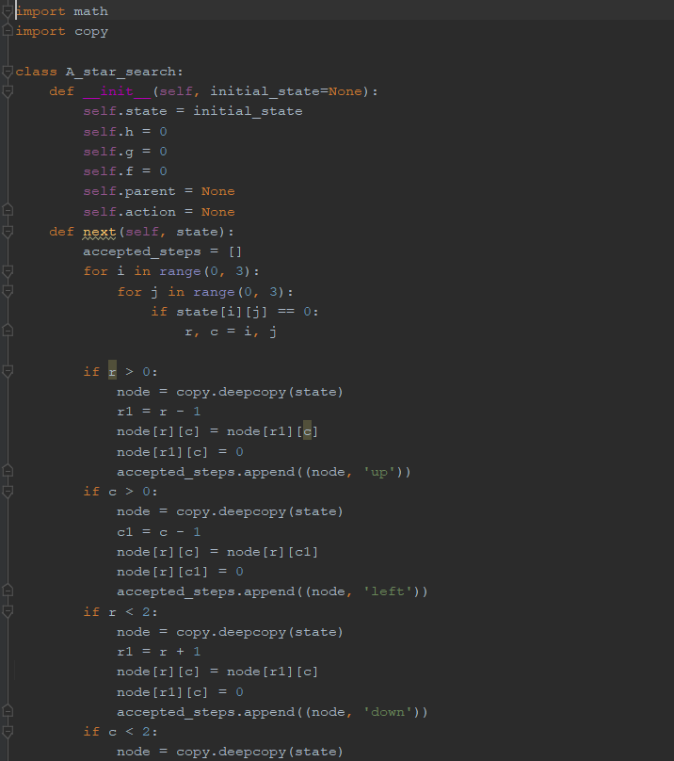 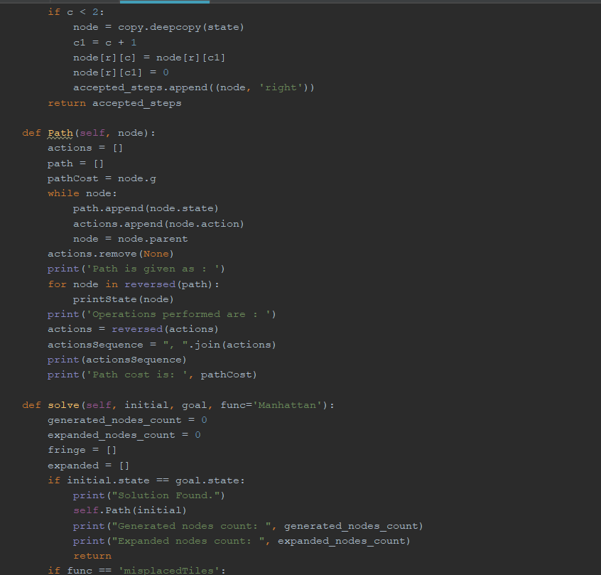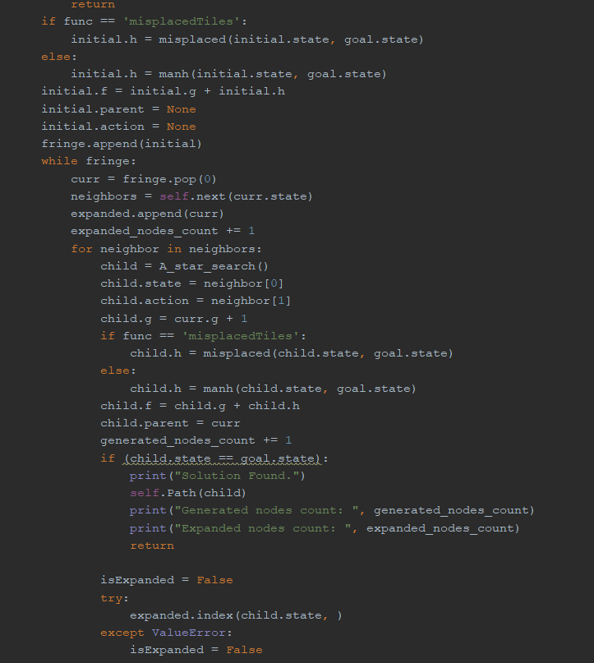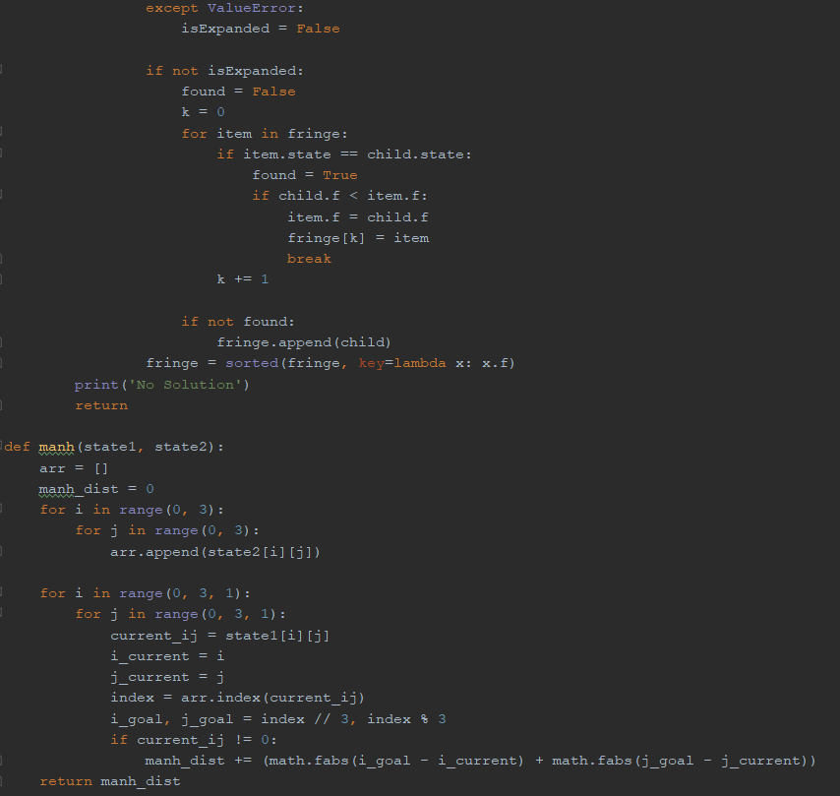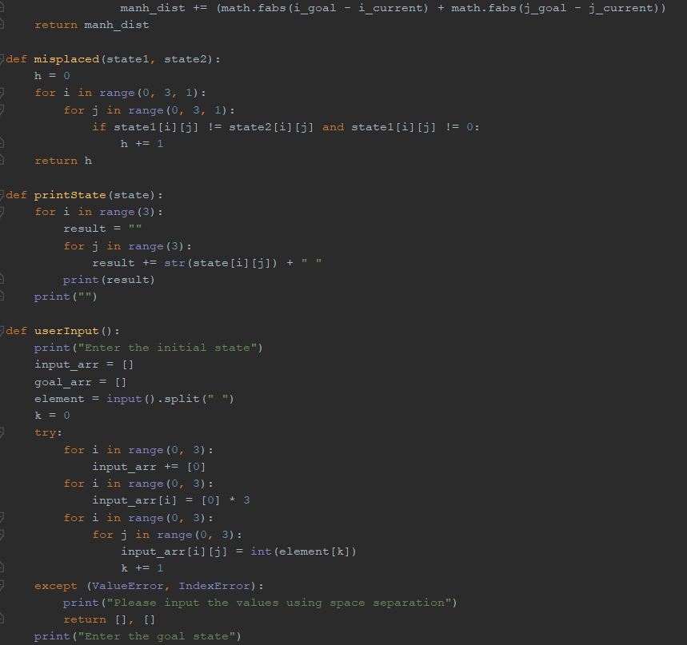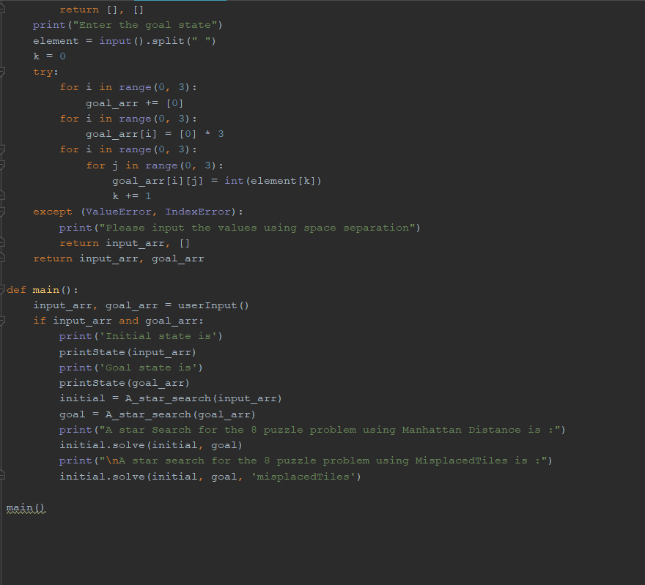

4.INPUT/OUTPUT :-

Example 1 :

Enter the initial state

1 2 3 7 4 5 6 8 0

Enter the goal state

1 2 3 8 6 4 7 5 0

Initial state is

1 2 3

7 4 5

6 8 0

Goal state is

1 2 3

8 6 4

7 5 0

A star Search for the 8 puzzle problem using Manhattan Distance is :

Solution Found.

Path is given as :

1 2 3

7 4 5

6 8 0

1 2 3

7 4 0

6 8 5

1 2 3

7 0 4

6 8 5

1 2 3

7 8 4

6 0 5

1 2 3

7 8 4

0 6 5

1 2 3

0 8 4

7 6 5

1 2 3

8 0 4

7 6 5

1 2 3

8 6 4

7 0 5

1 2 3

8 6 4

7 5 0

Operations performed are :

up, left, down, left, up, right, down, right

Path cost is: 8

Generated nodes count: 26

Expanded nodes count: 9

A star search for the 8 puzzle problem using MisplacedTiles is :

Solution Found.

Path is given as :

1 2 3

7 4 5

6 8 0

1 2 3

7 4 0

6 8 5

1 2 3

7 0 4

6 8 5

1 2 3

7 8 4

6 0 5

1 2 3

7 8 4

0 6 5

1 2 3

0 8 4

7 6 5

1 2 3

8 0 4

7 6 5

1 2 3

8 6 4

7 0 5

1 2 3

8 6 4

7 5 0

Operations performed are :

up, left, down, left, up, right, down, right

Path cost is: 8

Generated nodes count: 73

Expanded nodes count: 25

Example 2 :

Enter the initial state

2 8 1 3 4 6 7 5 0

Enter the goal state

3 2 1 8 0 4 7 5 6

Initial state is

2 8 1

3 4 6

7 5 0

Goal state is

3 2 1

8 0 4

7 5 6

A star Search for the 8 puzzle problem using Manhattan Distance is :

Solution Found.

Path is given as :

2 8 1

3 4 6

7 5 0

2 8 1

3 4 0

7 5 6

2 8 1

3 0 4

7 5 6

2 0 1

3 8 4

7 5 6

0 2 1

3 8 4

7 5 6

3 2 1

0 8 4

7 5 6

3 2 1

8 0 4

7 5 6

Operations performed are :

up, left, up, left, down, right

Path cost is: 6

Generated nodes count: 17

Expanded nodes count: 6

A star search for the 8 puzzle problem using MisplacedTiles is :

Solution Found.

Path is given as :

2 8 1

3 4 6

7 5 0

2 8 1

3 4 0

7 5 6

2 8 1

3 0 4

7 5 6

2 0 1

3 8 4

7 5 6

0 2 1

3 8 4

7 5 6

3 2 1

0 8 4

7 5 6

3 2 1

8 0 4

7 5 6

Operations performed are :

up, left, up, left, down, right

Path cost is: 6

Generated nodes count: 20

Expanded nodes count: 7

Example 3:-

Enter the initial state

0 1 2 4 5 3 7 8 6

Enter the goal state

1 2 3 4 5 6 7 8 0

Initial state is

0 1 2

4 5 3

7 8 6

Goal state is

1 2 3

4 5 6

7 8 0

A star Search for the 8 puzzle problem using Manhattan Distance is :

Solution Found.

Path is given as :

0 1 2

4 5 3

7 8 6

1 0 2

4 5 3

7 8 6

1 2 0

4 5 3

7 8 6

1 2 3

4 5 0

7 8 6

1 2 3

4 5 6

7 8 0

Operations performed are :

right, right, down, down

Path cost is: 4

Generated nodes count: 10

Expanded nodes count: 4

A star search for the 8 puzzle problem using MisplacedTiles is :

Solution Found.

Path is given as :

0 1 2

4 5 3

7 8 6

1 0 2

4 5 3

7 8 6

1 2 0

4 5 3

7 8 6

1 2 3

4 5 0

7 8 6

1 2 3

4 5 6

7 8 0

Operations performed are :

right, right, down, down

Path cost is: 4

Generated nodes count: 10

Expanded nodes count: 4

Example 4:

Enter the initial state

1 2 3 4 6 5 8 7 0

Enter the goal state

1 2 3 4 5 6 7 8 0

Initial state is

1 2 3

4 6 5

8 7 0

Goal state is

1 2 3

4 5 6

7 8 0

A star Search for the 8 puzzle problem using Manhattan Distance is :

Solution Found.

Path is given as :

1 2 3

4 6 5

8 7 0

1 2 3

4 6 5

8 0 7

1 2 3

4 0 5

8 6 7

1 2 3

4 5 0

8 6 7

1 2 3

4 5 7

8 6 0

1 2 3

4 5 7

8 0 6

1 2 3

4 5 7

0 8 6

1 2 3

0 5 7

4 8 6

1 2 3

5 0 7

4 8 6

1 2 3

5 7 0

4 8 6

1 2 3

5 7 6

4 8 0

1 2 3

5 7 6

4 0 8

1 2 3

5 0 6

4 7 8

1 2 3

0 5 6

4 7 8

1 2 3

4 5 6

0 7 8

1 2 3

4 5 6

7 0 8

1 2 3

4 5 6

7 8 0

Operations performed are :

left, up, right, down, left, left, up, right, right, down, left, up, left, down, right, right

Path cost is: 16

Generated nodes count: 1337

Expanded nodes count: 496

A star search for the 8 puzzle problem using MisplacedTiles is :

Solution Found.

Path is given as :

1 2 3

4 6 5

8 7 0

1 2 3

4 6 5

8 0 7

1 2 3

4 6 5

0 8 7

1 2 3

0 6 5

4 8 7

1 2 3

6 0 5

4 8 7

1 2 3

6 8 5

4 0 7

1 2 3

6 8 5

4 7 0

1 2 3

6 8 0

4 7 5

1 2 3

6 0 8

4 7 5

1 2 3

0 6 8

4 7 5

1 2 3

4 6 8

0 7 5

1 2 3

4 6 8

7 0 5

1 2 3

4 6 8

7 5 0

1 2 3

4 6 0

7 5 8

1 2 3

4 0 6

7 5 8

1 2 3

4 5 6

7 0 8

1 2 3

4 5 6

7 8 0

Operations performed are :

left, left, up, right, down, right, up, left, left, down, right, right, up, left, down, right

Path cost is: 16

Generated nodes count: 3088

Expanded nodes count: 1129

5. Summarized Tabled :

|  |  |  |  |  |  |
| --- | --- | --- | --- | --- | --- |
| Example | Manhattan Distance | | Misplaced Tiles | | Path Cost |
| Generated | Expanded | Generated | Expanded |
| 1 | 26 | 9 | 73 | 25 | 8 |
| 2 | 17 | 6 | 20 | 7 | 6 |
| 3 | 10 | 4 | 10 | 4 | 4 |
| 4 | 1337 | 496 | 3088 | 1129 | 16 |

6. References:

1.Artificial Intelligence A Modern Approach, Stuart Russell and Peter Norvig

2.Wikipedia

3.[www.stackoverflow.com](http://www.stackoverflow.com)

4.www.geeksforgeeks.com